*Alchemy game*

**Design Document**

*Core concept*

Alchemist shop in rural wooded fantasy setting, acquires old book of recipes mostly incomplete/damaged.

Book serves as main progression driver/marker.

Ingredients can be grown and bought/acquired

Ingredients have alchemical sub-components which govern their use.

Recipes can be constructed crudely or delicately (amounts and process differ) for varying qualities of results.

Can brew potions, ointments, pastes, bombs, perfumes

*Processes – sub-divisible into processes for examination and processes for change*

Tiers of complexity that progress throughout game

Microscope (ye olde)

Heating – assation / calcination

Centrifuge

Pestle and mortar – boosts select aspects by 1.

Ablation – not sure

Amalgamation

distillation

Processes can separate/amalgamate or transform the alchemical sub-components

Automation of simple processes? (late game)

*Progression*

Customers arrive, can request specific concoction or buy existing stock. Can pay either with cash OR ingredients/equipment/favours/information

*Ingredients*

Plant matter – roots, leaves, petals, nuts/seeds, stems

Liquids – sap, blood, brine, complex creation from others, perhaps bases for concoctions

Powders – ash, stone, all sorts

Rocks/crystals/minerals/metals

Biological weird things – eggs, eyes, scales, tongues, hair

7 metals of alchemy

*False/useless ingredients* received from customers and tested for usability.

*Types of ingredients:* bases – liquids that are starting point for concoctions, e.g. water, alcohol, more exotic ones for more complex potions.

Powders

Coagulants?

Each ingredient made up of some combination of 12(?) atomic alchemical elements, arranged on a circle so some act opposite to others. Potions made by mapping this 12 sided circle with the right amounts.

**Resources**

Materials: 3dassets.one (eh so far), textures.com (eh), 3dtextures.me, cgbookcase.com, Sharetextures.com​, texturehaven.com, cc0textures.com, quixel.com, poliigon.com

Materialize: for making materials

HDRI: hdrihaven.com

<https://old.reddit.com/r/gamedesign/comments/mkwsbl/looking_for_reading_material_on_game_design/>

music: https://www.reddit.com/r/gamedev/comments/p4pz7c/i_made_some_music_for_an_unfinished_game_so_now_i/

http://chinaplus.cri.cn/recommended/1661/502785

ingredient ideas:

<https://www.reddit.com/r/DnD/comments/b74jwx/alchemy_low_magic_creations/>

<https://www.realmshelps.net/magic/items/alchemy.shtml>

<https://adamsouza.tripod.com/alchemy.html>

[https://www.dragonsfoot.org/forums/viewtopic.php?p=957931#p957931](https://www.dragonsfoot.org/forums/viewtopic.php?p=957931" \l "p957931)

<https://docs.google.com/document/d/1g-Rm_B8Bm98KeJx4MLQ4qnJyrREINYn67grthhRMG0k/edit>

<https://www.hogwartsishere.com/library/book/3214/chapter/4/>

<https://listfist.com/list-of-dungeons-dragons-5e-potions>

<https://drive.google.com/file/d/0B6h7d28uGOpkUC10QnQtbzFuNTg/view?resourcekey=0-zW4c7XUBI-szz0I2LIWCuQ>

<https://www.dndspeak.com/2019/06/07/random-potion-generator/>

<https://hobbylark.com/writing/potion-and-spell-ingredients>

Assets

<https://www.youtube.com/watch?v=B975bBfHTTg> - see description

- sites

https://www.syntystudios.com/

https://gamefromscratch.com/great-free-3d-model-sites-and-resources/

[https://www.polyhaven.com](https://www.polyhave.com/).

https://www.turbosquid.com/

https://www.sketchfab.com/

**ChatGPT output**

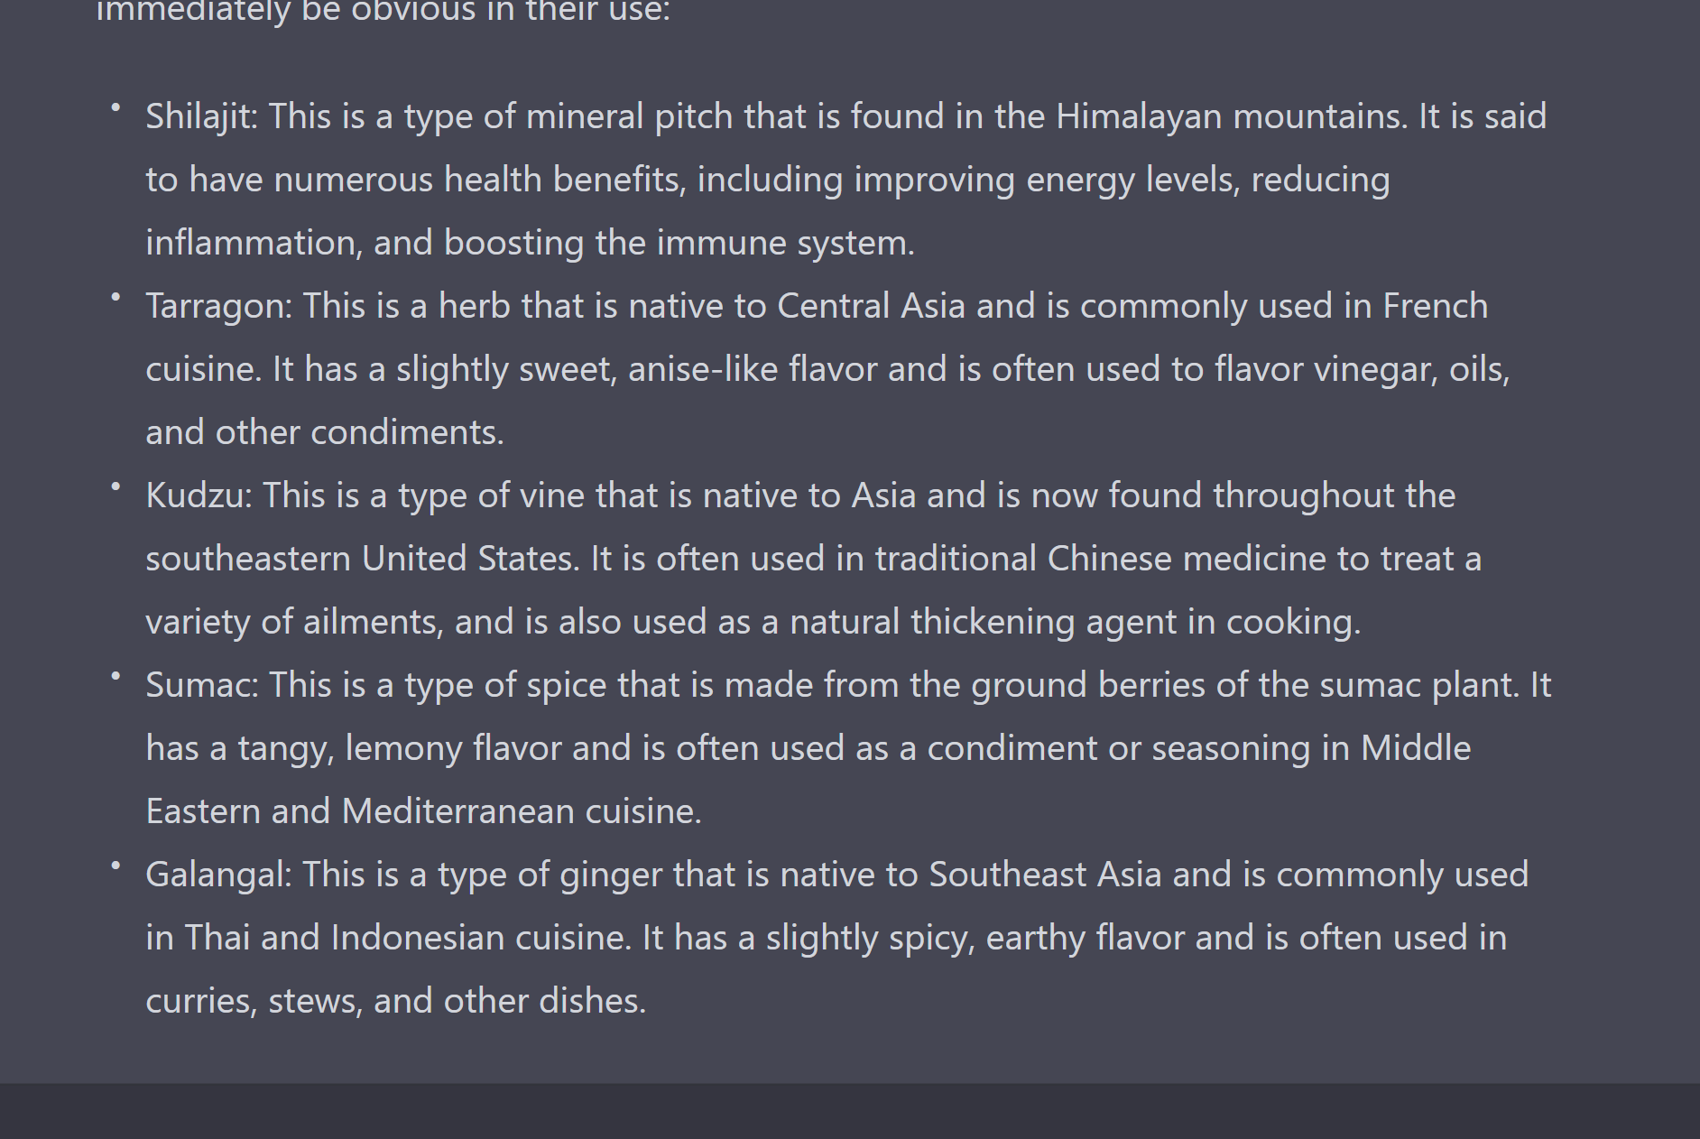

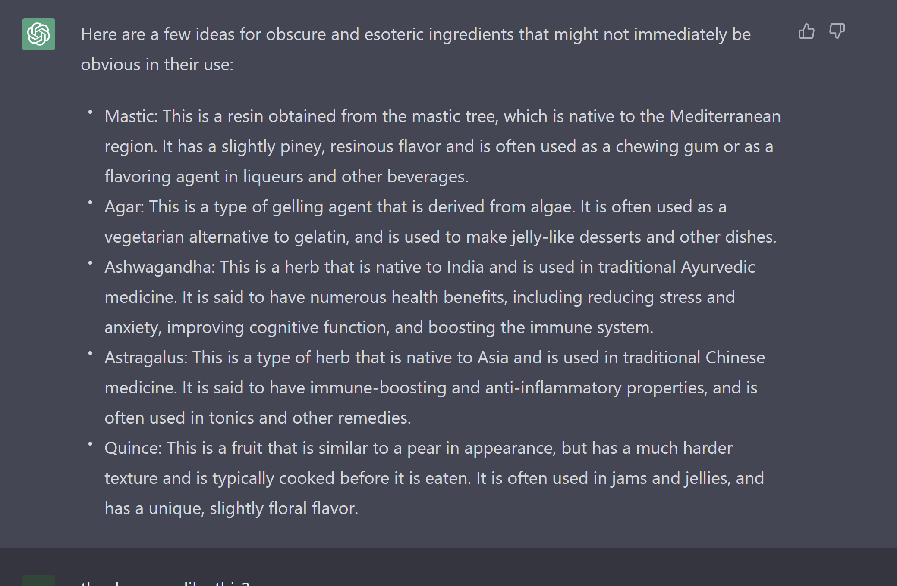

**General Ideas**

- star gazing mechanic, telescope, tower, moon door above cauldron, provides optional buffs/modifiers to brewing

- line recipes for potions to resemble shapes or symbols related to their effect. E.g. fire potion recipe of lines resembles flame.

- Radar diagram is instead seen via a tool (magnifying glass like) that can be used to view the image and reveal ‘components’. Otherwise appears merely as illustration.